**Date: 7/8/2019 IT204 Signals and Systems Lab 2**

**Exercise 1**

Generate the complex-valued signal

x(n)= exp(-0.1+j0.3)n , -10 ≤ n ≤ 10

and plot its magnitude, phase, the real part, and the imaginary part in four separate subplots.

**Program**

n=[-10:1:10]; alpha = -0.1+0.3j;

x=exp(alpha*n);

subplot(2,2,1); stem(n, real(x)); title('real part'); xlabel('n');

subplot(2,2,2); stem(n, imag(x)); title('imaginary part'); xlabel('n');

subplot(2,2,3); stem(n, abs(x)); title('magnitude part'); xlabel('n');

subplot(2,2,4); stem(n, (180/pi)*angle(x)); title('phase part'); xlabel('n');

**output**

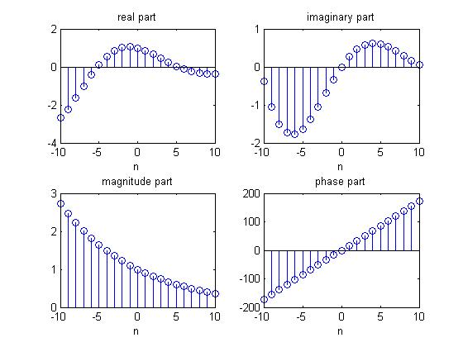

**Exercise 2**

Record 5 seconds of your speech with a microphone and play it back

**Program**

myVoice = audiorecorder;

disp('start speaking');

recordblocking(myVoice, 5);

disp('End of recording . Playing back…');

play(myVoice);

**Exercise 3**

Record audio with a sampling frequency of 10000 Hz.

**Program**

fs=10000;

recObj=audiorecorder(fs, 8, 1);

recordblocking(recObj, 8);

y=getaudiodata(recObj);

sound(y, fs);

**Exercise 4**

Read the audio signal. Plot the received signal as a function of time. (You can try to find a wav file online. Here is one I used <http://signalsandsystems.wdfiles.com/local--files/matlab-assignments/anykey.wav>)

**Program**

[y, fs]= audioread('D:\Phd\NIK doc\lab experiments\anykey.wav');

t=1/fs:1/fs:length(y)/fs;

plot(t,y);

**Exercise 5**

Calculate the convolution of two finite length sequences. Plot the signals.

**Program**

clc;

clear all;

close all;

x1=input('Enter the first sequence x1(n) = ');

x2=input('Enter the second sequence x2(n) = ');

L=length(x1);

M=length(x2);

N=L+M-1;

y=conv(x1,x2);

disp('The value of y are = ');

disp(y);

n1=0:L-1;

subplot(311);

stem(n1,x1);

grid on;

xlabel('n1-->');

ylabel('amplitude --->');

title('First sequence');

n2=0:M-1;

subplot(312)

stem(n2,x2);

grid on;

xlabel('n2-->')

ylabel('amplitude --->');

title('Second sequence');

n3=0:N-1;

subplot(313)

stem(n3,y);

grid on;

xlabel('n3-->')

ylabel('amplitude --->');

title('Convolved output');

**Output**

Enter the first sequence x1(n) = [1 2 3 4 5]

Enter the second sequence x2(n) = [5 8 3 5 4 6]

The value of y are =

5 18 34 55 80 81 59 59 44 30

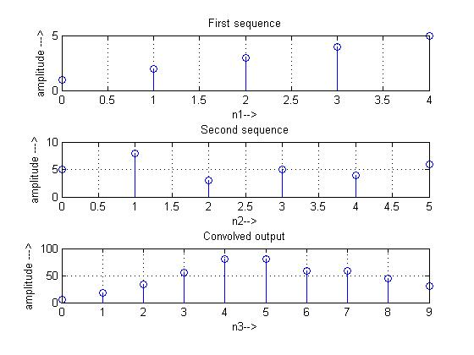

**Exercise 6**

Find the linear convolution of x[n] = [7 5 4 0] and h[n] = [0 3 6 2 9]

**Exercise 7**

To display image data

**Program**

moon = imread('moon.tif');

imshow(moon);

**Exercise 8**

Addition of two images

**Program**

I = imread('rice.png');

J = imread('cameraman.tif');

K = imadd(I,J,'uint16');

figure, imshow(I);

figure, imshow(J);

figure, imshow(K,[]);

**Exercise 9**

Perform median filter to remove noise from image

**Program**

I = imread('eight.tif');

figure, imshow(I)

J = imnoise(I,'salt & pepper',0.02); % noises are added

K = medfilt2(J); % use median filter

imshowpair(J,K,'montage')

**Exercise 10**

Remove noise by using average filter

Note: Use MATLAB help command for syntax and description.

For example: Type help audiorecorder in MATLAB command window.

**Exercise 11**

Create one trailer (like movie trailer) which is one minutes duration and give your voice for that trailer video. The theme of the trailer video should be any current national issues (For example, Swachh Bharat Mission, Water Conservation etc.). Submit this video to your CR mail id. Give your Register number as a file name.

Deadline to submit Exercise 11 : 8/8/2019